The Day of the Lord
June 21, 2016
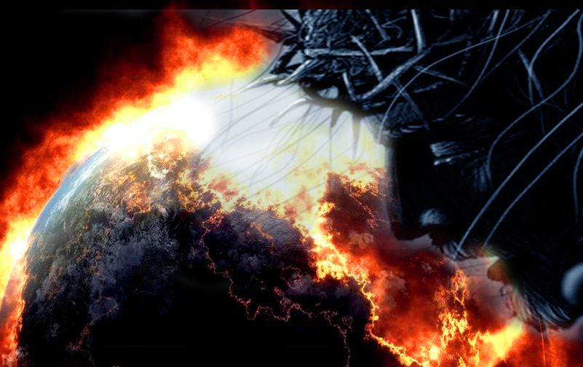
May the Lord be ever before you. May He keep you in His Peace.

My dear Heartdwellers, the Lord has been telling us for weeks that He is going from minute to minute before this war erupts. And today the news is spreading that the nations are coming into position for war. I doubt that many know what is happening or understand the repercussions. The world still holds their fascination. But soon, the world as we know it will no longer exist, and nothing will be left but God - or the false security of the government that cannot be trusted.

Perhaps our prayers will again push the events back. But we are at DEFCON 3 and the deployment of both Russian, NATO and American troupes is undeniably a serious sign of impending war.

As I came into prayer, and sat to listen for the Lord's voice, He began: "Now it is your turn to hold Me close over your heart. As I must look upon the faces of mothers and children that will be separated for eternity. And yet, My provision in Heaven for such as these is total loss of memory, just as I do with the aborted babies. So many families will be separated and perish. You cannot relate to this, because you have never had a family - other than your own children, who now live far away.

"Clare, the saddest part of all of this is that there are so many who never took the time to know Me. I knocked and knocked, but no one came to the door. Now death is at the door. Very much unknown to them, it is at their door. And really, for most, it is too late. They have rejected My attempts so many times that now their hearts are hardened and impenetrable.

"There will be so many that will not even be awake; they will go in their sleep. This is going to be the greatest tragedy Earth has ever known. Never were there so many souls on the Earth, never was there My provision on Earth for their salvation. The tragedy is that the opportunities to live in Heaven with Me forever have been lost to these souls and they will look back and see what they pushed away time and time again.

"There will be no excuses. 'Bible fundamentalists were too harsh. Others were not intellectual enough. Others were not loving enough. Pentecostals were too intense.' None of these will fly, for I sent them Mother Theresa’s, missionaries, bishops and priests - highly trained and still in love with Me. Evangelists and miracles of healing. They have seen in this world the entire gamut of My servants and heard their miraculous, self-sacrificing stories and still pushed Me away. So indeed, there will not be one excuse.

"This is the time spoken of in Joel, where judgment must come to pass."

1Blow a trumpet in Zion,
And sound an alarm on My holy mountain!
Let all the inhabitants of the land tremble,
For the day of the LORD is coming;
Surely it is near,

2A day of darkness and gloom,
A day of clouds and thick darkness.
As the dawn is spread over the mountains,
So there is a great and mighty people;
There has never been anything like it,
Nor will there be again after it
To the years of many generations.

3A fire consumes before them
And behind them a flame burns.
The land is like the garden of Eden before them
But a desolate wilderness behind them,
And nothing at all escapes.

4Their appearance is like the appearance of horses;
And like war horses, so they run.

5With a noise as of chariots
They leap on the tops of the mountains,
Like the crackling of a flame of fire consuming the stubble,
Like a mighty people arranged for battle."

And later on, in Joel 2 it says:

20“But I will remove the northern army far from you,
(I believe He's speaking of the Russians here)
And I will drive it into a parched and desolate land,
And its vanguard into the eastern sea,
And its rear guard into the western sea.
And its stench will arise and its foul smell will come up,
For it has done great things.”

And then there were Scriptures in Joel 3 that He quickened to me:

2I will gather all the nations
And bring them down to the valley of Jehoshaphat.
Then I will enter into judgment with them there
On behalf of My people and My inheritance, Israel,
Whom they have scattered among the nations;
And they have divided up My land.

9Proclaim this among the nations:
Prepare a war; rouse the mighty men!
Let all the soldiers draw near, let them come up!

10Beat your plowshares into swords
And your pruning hooks into spears;
Let the weak say, “I am a mighty man.”

11Hasten and come, all you surrounding nations,
And gather yourselves there.
Bring down, O LORD, Your mighty ones.

12Let the nations be aroused
And come up to the valley of Jehoshaphat,
For there I will sit to judge
All the surrounding nations.

13Put in the sickle, for the harvest is ripe.
Come, tread, for the wine press is full;
The vats overflow, for their wickedness is great.

14Multitudes, multitudes in the valley of decision!
For the day of the LORD is near in the valley of decision.

15The sun and moon grow dark
And the stars lose their brightness."

And at that point, as I was reading through this, I got somewhat distracted. And I said, "Lord, You don't seem to be heavy-hearted?"

And He said, "No, I am withholding from you My extreme torment. You could not endure the sight of it.

"See, I have told you again and again: I am at the door. It IS at the door, there is only the word of the Father missing. One word - and it is done. All the nations shall be involved. Do I not say, 'Gather the nations?' (Joel 3:2)

"There has been much repentance in Israel since the words of Nathan were given, much repentance. Still, the people have not followed My statutes and commands and this generation does not know Me. They know the flesh quite well, but Me? They do not know. It is a land divided, a spirit torn asunder…The young pursue the ways of the world, the elders repent for them. But I will have it divided no longer. The young will cry out to Me and change their ways, but not before multitudes perish.

"I will sift My people, and My grain I shall set aside in the granary. The chaff will be burnt with fire. But those who call upon Me in sincere contrition, I will spare. What is coming is horrific, because the weapons man has devised are beyond comprehension to destroy and annihilate. Yet the remnant will be set aside and they who know Me shall proclaim, 'Blessed is He Who comes in the Name of the Lord.'
"The whole world shall be engulfed in flames. My judgment will reach into the furthest corners and I, in turn, will be known as the Mighty One, Lord of Lords and King of Kings. Yet with the coming to power of the beast, there will be endless slaughter of those who profess My Name.

"I will provide for My remnant in the wilderness, as it is written. Not only those of Jerusalem, but those grafted into the vine, (He's speaking of Christians there) in places of refuge around the world. My people, do not fear those who kill the body, but He who has power over your souls.

"The faith of all shall be shaken in the coming war, but I shall faithfully abide with them and remove My Bride in a timely fashion. All of you, My faithful Ones, all that you have or will suffer is to bring the lost to salvation.

"Please stand fast and keep your eyes on the prize. This life is but a fleeting breath; your eternity is guaranteed to be glorious. Keep your eyes on the prize and cling to Me. Call upon Me in that Day and you shall be saved - this is My promise to you.

"And for those who are finally hearkening to My voice, understand: I am in control. All these things are written thousands of years ago; I have given My prophets utterance that they would bear witness to what is coming. Rest assured, this was done to prepare you to receive the faith, that you would stand in this Day and not give in to lies and despair.

"Stand on My Words. Watch them unfold. Know that I am in total control and I will keep you in the palm of My Hand and bring you into eternal glory. Do not fear any man, any weapon, any demise. Cleave only to Me and I shall make Myself clearly known to you in that hour, and you shall have Peace.

"I am coming. I surely am."

